Title of Your Invention
First Name, Last Initial
Age
State or Country

Have a great idea for an invention. (required step)

Investigate inventions and ideas of the past (required step)

Draw pictures and diagrams to show your invention and how it might work. (required step)

Build your prototype or model of your invention.

Test your invention.

Keep improving your invention.

Market your invention to people who might buy it. (required step)

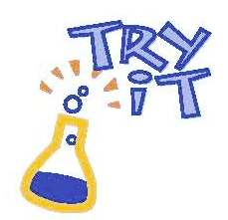
Things to think about as you complete your submission….
- Describe the problem you want to solve. The real world-problem may be one that all the people in your neighborhood face, something that all your friends complain about, or an issue you talk about where you live. It could also be about a bigger, global problem that affects many people.
- Your entry must describe how you help solve the problem by inventing something new.
- Make a list of possible ways to solve this problem.
- How have people tried to solve this problem in the past?
- Think of how you can improve on other solutions.
- Draw pictures and diagrams to show your invention and how it might work.
- Include video, photos and text of the steps you take in building your prototype or model.
- Show your model to friends and hear what they say. Write down their suggestions.
- Perform some experiments to find out how well you prototype works. Write down the results of each test.
- Adjust your prototype or model based on the suggestions of your friends or findings of your experiments.
- Give your invention a name and explain why people should buy it.

Take time to make your presentation impressive. Use diagrams, video, voice or photos. You may include multiple pages for each step of the invention process.

